**Transform FM in Excel spreadsheet to Max file for import of FM in EA and to create publication of FM**

1. In Excel ~~or LibreOffice~~
2. Create the Functional Model Content
3. Convert the Functional Model Content into the Functional Model Import Spreadsheet according to the Import Template, if not already started with that

1. Make sure there is no column or row merging, start by pasting values only

2. Extra columns are ignored

3. Check of CC met ‘??’ in de CC# kolom wel mee zijn gekomen

4. Toevoegen opmerking in template: CC# SHALL be a number!

5. Row# should start with ‘3’ and is for reference back from the eap (and publication) to the import sheet

1. Save the spreadsheet as "XML Spreadsheet Excel 2003” with extension “.excel.xml” ~~or "Flat XML ODF Spreadsheet .fods"~~
2. In EA

Pre- requirements:

* 1. EA v13.x installed
  2. MAX installed : https://app.box.com/s/ndhk4hnh2adzcho42sus
  3. SaxonHE9-7-0-4N-setup installed per MAX instruction

1. Create new Project

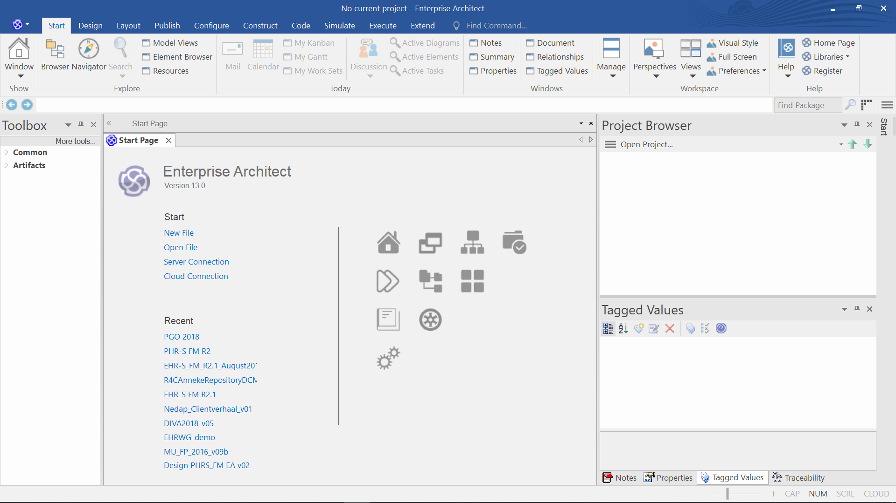

The Windows Explorer opens, choose the directory you want to save the project in, give the project a name. A Model Wizard will be opened by EA. Just click on Cancel. See image below.

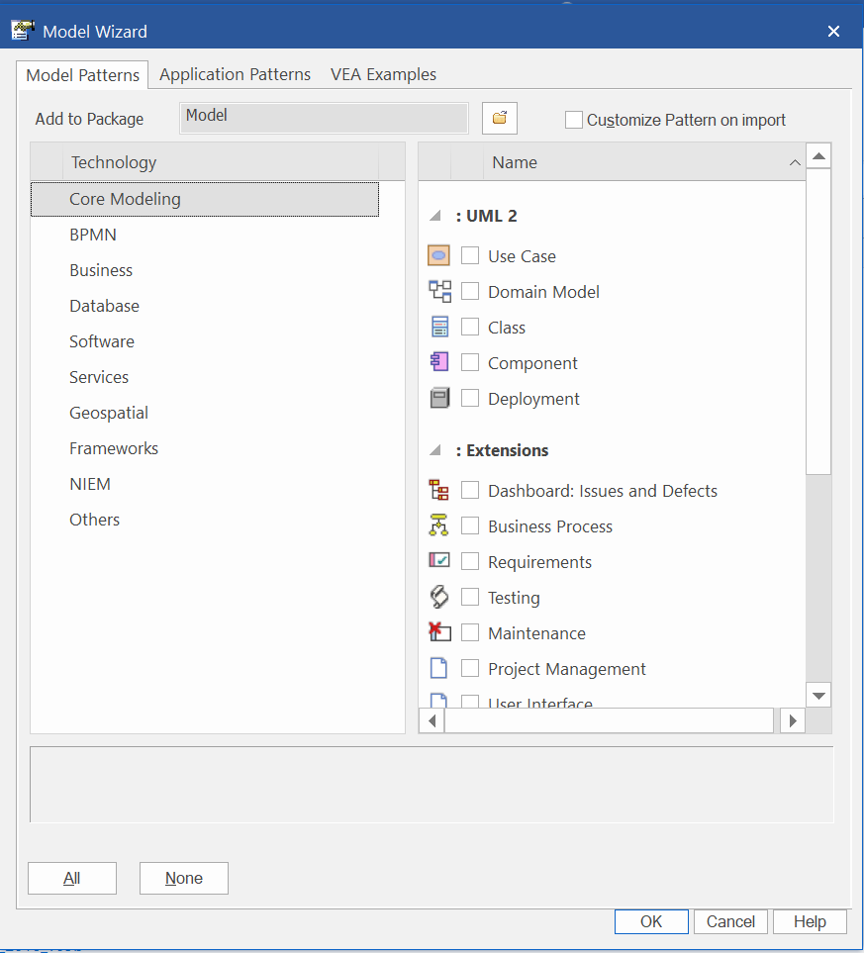

In the project browser of EA a Model was created. See image below.

Add a View by right click, Add and choose View. See image below.

Create new View: Name it and choose Simple. Click OK.

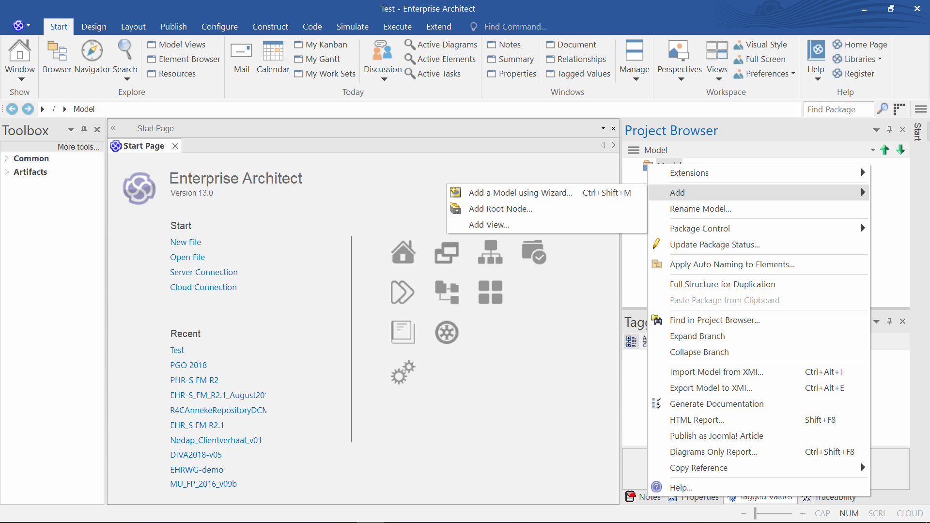

1. Create a View in the Model

|  |  |
| --- | --- |
| Result |  |

1. Work in Command Prompt

Go to the Windows logo left under on your screen.



Type cmd. The Command Prompt will appear. See image below.

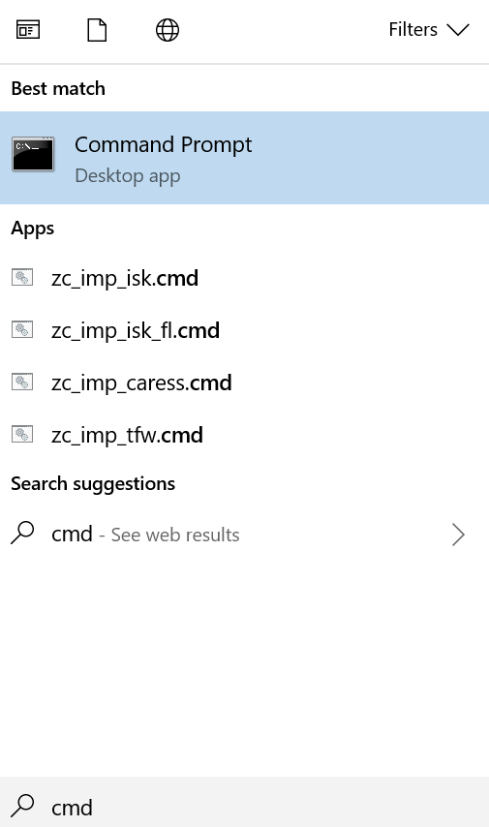

Choose Command Prompt as indicated in the image.

A screen as shown below will appear.

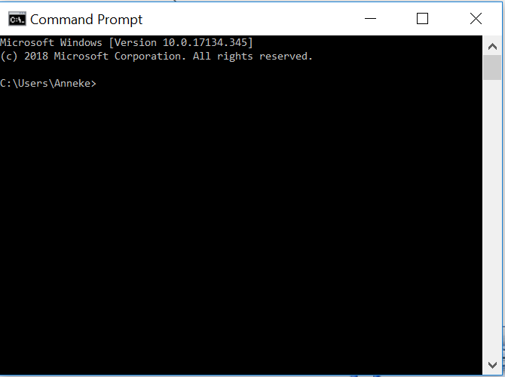

Below in the image is shown that the command on the top was wrong.

To check if the right version of Saxon is installed use the file path where Saxon is installed. In this case on C:\ProgramFiles\Saxonica\SaxonHE9.7N\bin>

After that D: was entered because the files that are needed for the transformation are on D:

1. Command line call XSLT

transform -s:"PHR_S_FM 20180819.excel.xml" -xsl:fm-excelxml2max.xslt -o:"PHR_S_FM 20180819.max"

After that the command line as described in item 3 was entered. The max file of the FM was created in the folder that was defined D: etc.

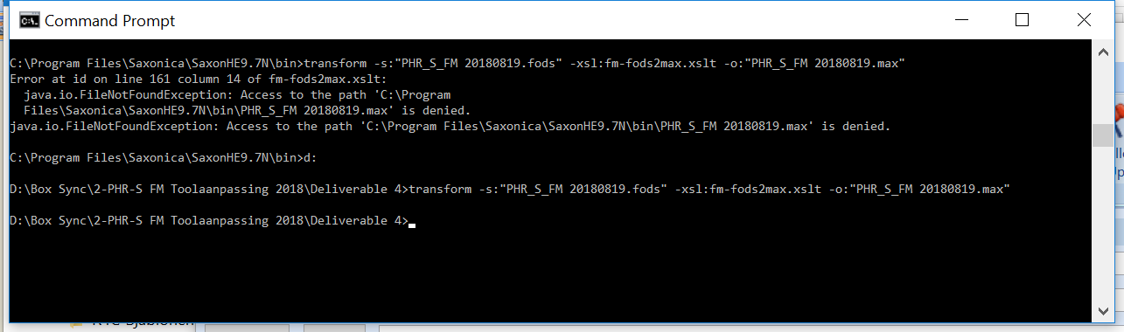

1. Import the MAX XML file “PHR_S_ FM 20180819.max”
2. Done

